|  |
| --- |
| ALS |
| Modern Physics SH1012 |

|  |
| --- |
| Mattias Jönsson 940425-0673 matjon4@kth.se Yue Jiao 911024-7799 yj@kth.se  2015-05-15 |

Introduction

One of the most important methods of studying properties of a material within modern physics is the spectroscopy. It is because that the spectroscopy of different atoms or molecules will too be different. However it is not that trivial how we get information from it. So we will demonstrate the theory and the method in this experiment. Here we shall try to determine the molecular vibrational constant and the Morse potential function of molecular iodine I2X1Σ ground state. And then compare them to other people’s result from reliable sources.

Theory

To study the vibrational property of the iodine in ground state we can use a laser with a certain wavelength to excite the molecule. In this experiment we use a NeHe 543.5 nm laser to excite the iodine from the ground state I2X1Σ to the excited state B3Π0. This process shall happen because the energy of this wavelength of NeHe coincide with the difference of energy between there states. As a consequence of that, the molecule will jump back to lower energy levels, and release photons with specific energies that correspond to those energy level. And that can be observed by spectroscopy which we are using in this experiment. The result should be a characteristic spectrum consisting mainly of different peaks of detected photons for certain wavelengths.

To describe the shared potential of atoms in a two-atomic molecule, we can use the Morse function to approximate that. It is given by the equation

$$V\left(r\right)=D_{e}{\left[1-e^{a\left(r_{e}-r\right)}\right]}^{2}$$

Here $D_{e}$ is the dissociation energy in $cm^{-1}$. $a$ is the Morse potential constant in $Å^{-1}$. $r$ is the interatomic distance in molecule and $r_{e}$ is the equilibrium interatomic distance. they have units $Å$.

And then we can solve the Schrödinger equation for this Morse function to get the quantized vibrational energy level $E_{v}$. For the ground state we have following relationship,

$$G\left(v\right)=\frac{E_{v}}{hc}=ω_{e}\left(v+\frac{1}{2}\right)+ω_{e}x_{e}{\left(v+\frac{1}{2}\right)}^{2}+ω_{e}y_{e}{\left(v+\frac{1}{2}\right)}^{3}, v=1,2,3…$$

Here $ω_{e}$, $ω_{e}x_{e}$ and $ω_{e}y_{e}$ are the rotational constants and $v$ is the vibrational constant of the molecule.

And we know that that the energy corresponding to the wavelength of NeHe laser is going to excite the molecule to its state where $v=26$. Then we will get another equation with different constant.

$$F\left(v\right)=T_{e}+ ω_{e}^{'}\left(v+\frac{1}{2}\right)+ω_{e}x_{e}^{'}{\left(v+\frac{1}{2}\right)}^{2}+ω_{e}y_{e}^{'}{\left(v+\frac{1}{2}\right)}^{3}, v=1,2,3…$$

With these two equations we can calculate the energy difference.

$$σ_{v}=\frac{1}{λ_{v}}=\frac{f_{v}}{c}=\frac{f_{v}h}{ch}=\frac{ΔE}{hc}=F\left(v=26\right)-G(v)$$

So, if we take the difference between two adjacent fluorescent emissions we will get

$$Δ_{σ}=σ_{v}-σ_{v+1}=\left[F\left(v=26\right)-G\left(v\right)\right]-\left[F\left(v=26\right)-G\left(v+1\right)\right]=G\left(v+1\right)-G(v)$$

Then we can define that

$$Δσ=ΔG\left(v+\frac{1}{2}\right)=G\left(v+1\right)-G\left(v\right)=ω_{e}-2ω_{e}x_{e}-2vω_{e}x_{e}$$

We want to determine the vibrational constant $v$ from the equation above. However the $σ_{v}$ is observed in the experiment and the validity of equation. So one can conclude that the equation above is a linear equation of $v$. Therefore we can decide the $ω_{e}$ and the $ω_{e}x_{e}$ by plotting the observed value off differences $Δσ$ as a function of $v$.

If we calculate the sum of all the $ΔD(v+\frac{1}{2})$ for all $v$, we shall get an approximate of $D_{e}$ which is following:

$$D_{e}=D_{0}=\frac{ω_{e}^{2}}{4ω_{e}x_{e}}$$

To find $ω_{e}x_{e}$ we shall use the derivative of the Morse function and then we shall get:

$$ω_{e}x_{e}=\frac{ha^{2}}{8π^{2}cμ}$$

Here $h$ is the Plancks constant, $c$ is the speed of light, $μ$ is the reduced mass in unit kg which is

$$μ=\frac{m_{1}m_{2}}{m_{1}+m_{2}}$$

$m_{1}$ and $m_{2}$ here are masses of atoms inside the molecule and in our experiment the value if equal to the mass of the iodine atom.

And from literature we can find out that the rotation constant $B_{e}$ can be expressed as following

$$B_{e}=\frac{h}{8π^{2}cμr_{e}^{2}}$$

So at last we put all equation above together and we will be able to express $ω_{e}$ and $ω_{e}x_{e}$ with the observed statistics.

In the experiment part we can use ordinary lamp to measure the relationship between the wavelength of incoming light and the channel number inside the software we are using with the help of grating with known passing wavelength. The grating shall only let light with a certain wavelength pass.

Experimental Setup

|  |  |
| --- | --- |
| HeNe laser with wavelength 543.5nm | A test cell containing iodide, $I_{2}$ |
| A focusing lens | A monochromatic Hg filters |
| A spectrometer | A computer for analyzing |
| Ordinary white light |

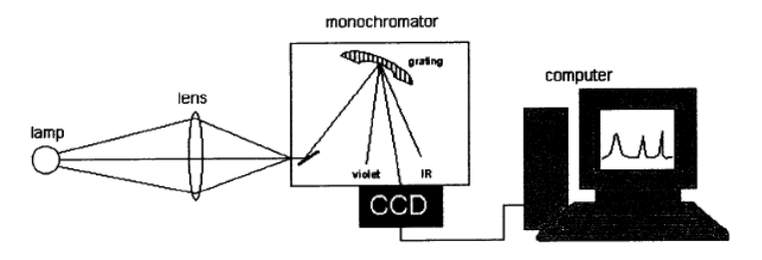

Step 1. Calibration CCD

We put a mirror in front of the SPE to reflex the light into it. Then we put a positive lens between the mirror and the SPE to gather the light. Now we start the software and check if there is a reading of anything. After we have gotten a reading we pause the software and put a grating just in front of the SPE so we can measure a new result. We adjust the ExpT which is the exposure time so we get a visible and sharp peak. We change the software to Peak Mode and take the value of the peak we find. When we find two peaks we record both. And we record also the wavelength corresponds to the peak which we already know. For the second peak if there is one we use the wavelength times 2. We measure four times channel number with four different gratings. And we get totally 7 relation between wavelength and channel numbers. We plot the result and get a linear relationship. And we calculate the first-degree polynomial to fit the relationship. The polynomial is needed later for measurement.

Step 2. Laser spectroscopy

First we try to make the room as dark as possible. Then we start a HeNe laser and let it shoot through a container that contains iodine. We put a lens between SPE and the excited iodine cell and put a white paper at where the SPE stand. We move around the lens until we get a sharp picture of the laser on the paper. Then we remove the paper there and put a paper in front of iodine cell to block the light from laser. Then we change the software so it measures one time and then set that as background base. Then we change the software back to continue measuring and remove all papers and measure the laser by SPE. We get a graph with a lot of peaks and we record all of the channel numbers associate with ordinal number of the peaks. These are all the statistics we need. Now the experiment part is done.

Results

Part 1: Calibration

|  |  |  |  |  |  |  |  |  |
| --- | --- | --- | --- | --- | --- | --- | --- | --- |
| Wavelength [Å] | 4047 | 4358 | 5461 | 5780 | 8094 | 8716 | 10922 | 11560 |
| Channel numbers | 617 | 673 | 867 | 947 | 1387 | 1505 | 1913 | 2035 |

From this table we can calculate the relationship between the wavelength of incoming light and the channel number by doing the least square fit of those parameters, i.e. calibration. The figure is showed as following.

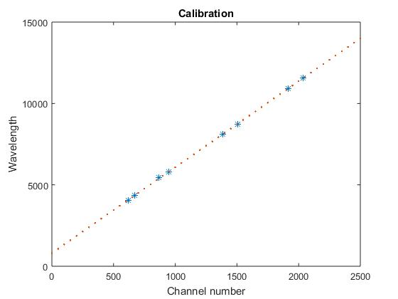

We will get that $λ=5.2767c+808.3531$ where c is the channel number.

Part 2: Spectroscopy

We can get the following peaks from the figure. And we can with the calibrated result to calculate the corresponding wavelength and the differences of wavelengths at the same time.

|  |  |  |  |
| --- | --- | --- | --- |
| Channel | Wavelength [Å] | Differences of wavelength [${1Å}^{-1}={10}^{8}cm^{-1}$] | Missed channel |
| 896 | 5420 | 2,28E-06 |  |
| 909 | 5488 | 1,89E-06 |  |
| 920 | 5545 | 2,35E-06 |  |
| 934 | 5618 | 2,1E-06 |  |
|  |  | 2,1E-06 | * |
| 960 | 5754 | 2,18E-06 |  |
| 974 | 5827 | 1,98E-06 |  |
| 987 | 5895 | 2,08E-06 |  |
| 1001 | 5968 | 1,88E-06 |  |
| 1014 | 6036 | 2,12E-06 |  |
| 1029 | 6114 | 2,04E-06 |  |
|  |  | 2,04E-06 | * |
| 1059 | 6271 | 1,97E-06 |  |
| 1074 | 6349 | 1,79E-06 |  |
| 1088 | 6422 | 2,12E-06 |  |
| 1105 | 6511 | 1,94E-06 |  |
| 1121 | 6594 | 1,9E-06 |  |
| 1137 | 6678 | 1,88E-06 |  |
|  |  | 1,88E-06 | * |
| 1170 | 6850 | 2,08E-06 |  |
| 1189 | 6949 | 1,5E-06 |  |
| 1203 | 7022 | 2,19E-06 |  |
| 1224 | 7132 | 1,62E-06 |  |
| 1240 | 7216 | 1,88E-06 |  |
| 1259 | 7315 | - |  |

Here we get all the $Δσ$. We have put in several differences because of the Franck-Condon principle. This principle state that there are certain jumps between different states that are almost impossible. So there should be peaks at those places but it is not possible. We can add those imaginary peaks so the theory shall work. However we do not know precisely where to put those peaks than which channels these peaks should be between. So we choose the average of those two peaks lies at the side of them.

We will get the following figure:

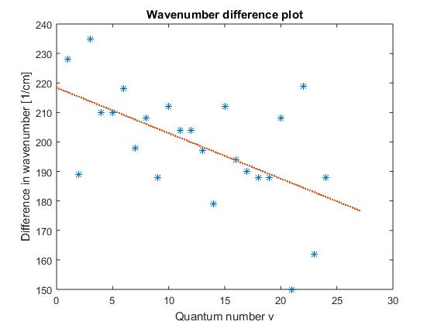

The linear fitting in this picture gives that the fitting equation is that

$$Δσ=-1.5404v+218.3804= ω_{e}-2ω_{e}x_{e}-2vω_{e}x_{e}$$

So we get

$$\left\{\begin{aligned}-2ω_{e}x_{e}=-1.5404 \\ ω_{e}-2ω_{e}x_{e}=218.3804\end{aligned}\right. ⇒ \left\{\begin{aligned}ω_{e}x_{e}=0.7702 \\ ω_{e}=219.9208\end{aligned}\right.$$

So we find out that $ω_{e}x_{e}=0.7702 [cm^{-1}]$ and $ω_{e}=219.9208 \left[cm^{-1}\right]$.

With those values we can calculate the Morse function:

$$D_{e}=\frac{ω_{e}^{2}}{4ω_{e}x_{e}}≈15699 \left[{cm}^{-1}\right]=15700[{cm}^{-1}]$$

$$a=\sqrt{\frac{{8πcμω}_{e}x_{e}}{h}}≈1.70295×{10}^{10}\left[m^{-1}\right]=1.703 [Å^{-1}]$$

$$r_{e}=\sqrt{\frac{h}{8π^{2}cμB_{e}}}≈2.0607×{10}^{10}\left[m^{-1}\right]=2.061 [Å^{-1}]$$

Now we have all we need to calculate the Morse function $V\left(r\right)=D_{e}{\left(1-e^{a\left(r_{e}-r\right)}\right)}^{2}$. We shall get following plotting:

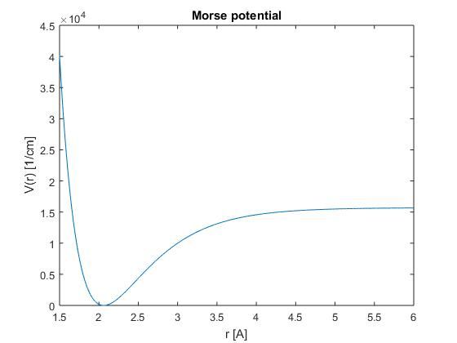

Conclusions

Here are all the values we are trying to find in this experiment.

|  |  |  |  |  |  |
| --- | --- | --- | --- | --- | --- |
| $$B_{e}[cm^{-1}]$$ | $$ω_{e}[cm^{-1}]$$ | $$ω_{e}x_{e}[cm^{-1}]$$ | $$D_{e}[cm^{-1}]$$ | $$a[Å^{-1}]$$ | $$r_{e}[Å]$$ |
| $$3.127$$ | $$219.9208$$ | $$0.7702$$ | $$15700$$ | $$1.703$$ | $$2.061$$ |

Discussion

We are overall satisfied with our results however there are some things that might be able to optimize.

First since the $D_{e}$ is just an approximate of $D_{0}$ which is the value we need. So there shall be a small error but it is not so big since $D_{e}$ is a quite good approximate.

We think the biggest error source come from that it is hard to determine if a point is a peak or not. We think it is because that the room where we did the experiment was not dark enough. So the background noisy light was quite strong.

References

Nist, 2015, <http://physics.nist.gov/PhysRefData/MolSpec/Diatomic/Html/sec6.html>